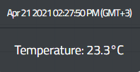**Grinning Machine: (Max-500Watt)**

**Sensor start point**

**Max. Temp**

**Motor start point & Min. Temp.**

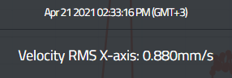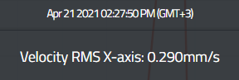

**Min. VRMS**

**Max. VRMS**

**Motor start point**

**Sensor star point**

**Motor start point**

**Max. VRMS**

**Sensor start point**

**Min. VRMS**

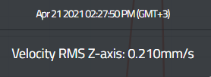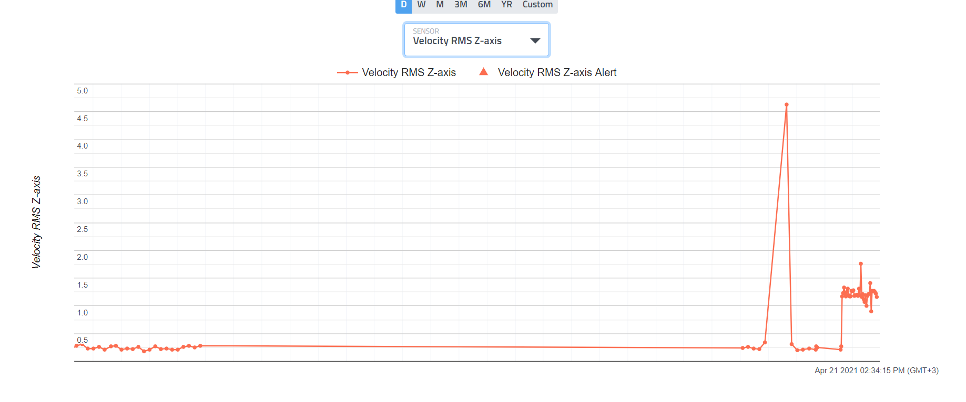**

**Max. VRMS**

**Motor start point**

**Sensor start point**

**Min. VRMS**

Report from (Grinning Machine < 15KW)

400watt

|  |  |  |  |  |  |  |  |
| --- | --- | --- | --- | --- | --- | --- | --- |
|  | Temperature(C) | VRMS  X-axis(mm/s) | VRMS  Y-axis(mm/s) | VRMS  Z-axis(mm/s) | Condition according to ISO | | |
| Start point | 23.30 | 0.29 | 1.97 | 1.17 | X-axis | Y-Axis | Z-axis |
| Minimum(Load) | 23.30 | 0.88 | 1.03 | 1.17 | Satisfactory | Unsatisfactory | Satisfactory |
| Maximum(Load) | 24.20 | 1.69 | 2.06 | 1.76 |
| Delta | 0.90 | 0.81 | 1.03 | 0.86 |

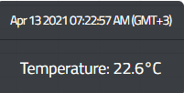**Pump motor:(Max-165Watt)**

**Max. Temp**

**Max. Temp**

**Min. Temp**

**Min. Temp**

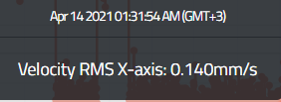

**Max. VRMS**

**Min. VRMS**

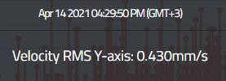

**Max. VRMS**

**Min. VRMS**

**

**Max. VRMS**

**Min. VRMS**

Report from (Pump Motor < 15KW)

|  |  |  |  |  |  |  |  |
| --- | --- | --- | --- | --- | --- | --- | --- |
|  | Temperature(C) | VRMS  X-axis(mm/s) | VRMS  Y-axis(mm/s) | VRMS  Z-axis(mm/s) | Condition according to ISO | | |
| Motor OFF time | 22.60 | 0.14 | 0.43 | 0.15 |  |  |  |
| Minimum | 22.60 | 0.14 | 0.14 | 0.15 | Satisfactory | Good | Good |
| Maximum(Load) | 45.60 | 1.63 | 0.43 | 0.50 |
| Delta | 23 | 1.49 | 0.29 | 0.35 |